|  |  |  |
| --- | --- | --- |
| Kd_Jenis | Jenis Cucian | Harga |
| 2 | Cuci Kering + Cuci Basang | 8000 |
| 3 | Cuci Basah + Parfum | 7500 |
| 4 | Paket Wangi + Bersih | 15000 |

Jenis Cucian

Pelanggan

|  |  |  |  |  |
| --- | --- | --- | --- | --- |
| Id pelanggan | Nama Pelanggan | Alamat | Telp | Jenis kelamin |
| 1 | Sultan | Cisarua | 088987567342 | Laki-Laki |
| 2 | Kimsul | Cisarua | 085345876567 | Laki-laki |
| 5 | Ryujin | Lembang | 081765562545 | Laki-laki |

Penerimaan



Pengguna

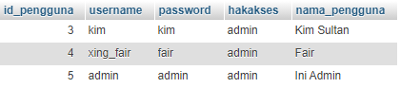

Transaksi

